- NUnit-Handson

using NUnit.Framework;
using CalcLibrary; // Namespace of your actual code

namespace CalculatorLibrary.Tests
{
[TestFixture]
public class CalculatorTests
{
private SimpleCalculator calc;

[SetUp]
public void Setup()
{
calc = new SimpleCalculator();
}

[TearDown]
public void TearDown()
{
calc.AllClear();
}

[TestCase(2, 3, 5)]
[TestCase(10.5, 5.5, 16)]
[TestCase(-1, -1, -2)]
public void Test_Addition(double a, double b, double expected)
{
double result = calc.Addition(a, b);
Assert.That(result, Is.EqualTo(expected));
}
}
}

OUTPUT:

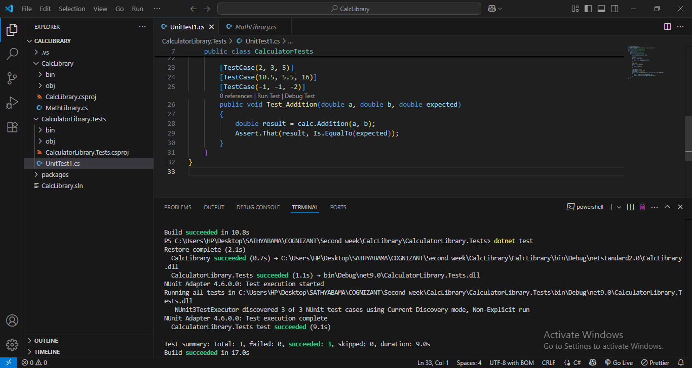

MailSender.cs
using System.Net;
using System.Net.Mail;

namespace MailServiceLib
{
public interface IMailSender
{
bool SendMail(string toAddress, string message);
}

public class MailSender : IMailSender
{
public bool SendMail(string toAddress, string message)
{
MailMessage mail = new MailMessage();
SmtpClient smtpServer = new SmtpClient("smtp.gmail.com");

mail.From = new MailAddress("your_email@gmail.com");
mail.To.Add(toAddress);
mail.Subject = "Test Mail";
mail.Body = message;

smtpServer.Port = 587;
smtpServer.Credentials = new NetworkCredential("username", "password");
smtpServer.EnableSsl = true;

smtpServer.Send(mail);
return true;
}
}
}

CustomerComm.cs
namespace MailServiceLib
{
public class CustomerComm
{
private readonly IMailSender _mailSender;

public CustomerComm(IMailSender mailSender)
{
_mailSender = mailSender;
}

public bool SendMailToCustomer()
{
return _mailSender.SendMail("cust123@abc.com", "Some Message");
}
}
}

UnitTest1.cs
using NUnit.Framework;
using Moq;
using MailServiceLib;

namespace MailServiceLib.Tests
{
public class CustomerCommTests
{
[Test]
public void SendMailToCustomer_ShouldReturnTrue()
{
var mockMailSender = new Mock<IMailSender>();
mockMailSender.Setup(x => x.SendMail(It.IsAny<string>(), It.IsAny<string>())).Returns(true);

var customerComm = new CustomerComm(mockMailSender.Object);

var result = customerComm.SendMailToCustomer();

Assert.IsTrue(result);
}
}
}

